

Project
Draft Project Proposal

 | Student Number | Surname | First Name
1 | 202402708 | Mokoena | Karabo
2 | 202306895 | Molomo | Karabo
3 | 202420029 | Thabethe | Kamohelo
4 | 202207325 | Thuto | Henderson

TITLE: School Feeding Program Distribution & Tracking System

INTRODUCTION

Everyday millions of African schoolchildren get meals from the National School Nutrition Program. The National School Nutrition Program is really helping these kids. Staff members at the National School Nutrition Program make meals for the students. They also distribute food packs to the schools. The National School Nutrition Program is doing a job of giving food to the students. These food packages are currently tracked manually through phone calls and written records. Schools are required to physically count their inventory and call the feeding plan office to report issues such as short deliveries or missing products. We do not have a system to keep track of who gets food, where the food goes. If the kids get the food. The food distribution process needs to be more accountable and transparent. This idea is about using a system to track the food from when it is delivered to when the kids eat it. The digital system will help us keep track of food distribution.

PROBLEM
Food parcels meant for schoolchildren are not properly tracked. This creates several serious problems:
- Manual stock tracking: Food deliveries are noted by school personnel in paper notebooks. Manual stock counts are sometimes imprecise or out-of-date.
- Delayed reporting: Schools are required to contact the nutrition program office when food is either short-delivered or missing. It takes time, and occasionally no calls are placed at all.
- Food theft: Food theft is a problem. Staff members and teachers sometimes take food that is meant for the kids. This. Nobody says anything, about it. The people who do this do not get in trouble because there is no way to keep track of who took what and when they took it. The food packages that are supposed to go to the kids are just. Nobody knows who did it. Food theft is still a problem because of this.
- No expiration monitoringBecause use-by dates are not routinely tracked food goes bad while it sits in storage.
- Lack of usage data: The nutrition program is unaware of the precise amount of food that each school consumes each day in comparison to what is supplied. It is difficult to spot discrepancies.
- Ineffective deliveries: Because timetables are not monitored, delivery vans may show up at random. While waiting, schools run out of food.

Affected Users:
- Schoolchildren: When food is taken, expires, or runs out, they go hungry.
- School principals: Without accurate records, they are unable to demonstrate that food is missing.
- Nutrition scheme managers: They are unable to identify troublesome schools or follow the path of delivery.
- Government: Food that never reaches children is a waste of taxpayer money.

SOLUTION
In order to track the distribution, storage, and consumption of food parcels in real time, this project suggests creating a Digital School Feeding Program Distribution & Tracking System. Schools, vendors, and government officials will be able to use a secure digital solution that will replace laborious paper-based monitoring.
The Brazilian National School Feeding Program digital school feeding monitoring system, which tracks food delivery and ensures accountability using digital technologies, is one of the successful foreign models that served as inspiration for the proposed system. The method in Brazil has increased openness, decreased food waste, and made sure that meals are effectively delivered to millions of kids.
The following elements will be part of the suggested system:
1. Digital Delivery Logging System
When the delivery workers get to a school they will use a tablet or a mobile application to write down the food deliveries. They will write down the date and the time of each delivery and how food they brought and what kind of food it is. The delivery workers will use this information to keep track of the food deliveries.. Digital confirmation of receipt will be provided by the school personnel. By doing this, the need for paper logs is eliminated and a permanent digital record is created.
This method is comparable to logistics tracking systems employed by businesses such as DHL, which use electronic delivery scanning and confirmation to guarantee precise tracking.
2. Real-Time Centralized Monitoring Dashboard
Nutrition plan managers will be able to track delivery in real time across all schools via a web-based dashboard. Which schools got food, when delivery took place, and whether there are any inconsistencies will all be displayed on the dashboard.
Centralized dashboards are used by the Estonian government's digital government services to effectively and openly monitor the provision of public services.
3. Inventory Management System with Expiry Tracking
The technology will be used by school personnel to track daily food consumption. The system will keep track of when things expire and figure out how much stock is left. When food is about to go the system will send alerts to employees so they know. This helps cut down on throwing away food that's still good and makes sure people do not eat bad food.
Healthcare systems, like the National Health Service in the UK use systems, like this to keep track of medicine and other supplies. They do this to avoid throwing away things that have expired. The National Health Service uses these systems a lot to manage their supplies and avoid waste from things expiring.
4. Automated Reporting and Alert System
The system will immediately alert administrators if food delivery are missing, delayed, or incomplete. Schools won't have to rely on phone calls to report problems. This guarantees that issues are resolved promptly and enhances response time.
Automated alerts are used by the Government of Singapore's public service monitoring systems to track service performance and boost operational effectiveness.
5. User Authentication and Accountability Tracking
There will be secure logins for every user. The user who tracks deliveries, modifies inventory, or reports problems will be noted by the system. This lowers theft and unauthorized access while establishing accountability.
Estonia's national digital identification system employs secure identity-based access control to guarantee accountability and transparency in the administration of public services.

Expected Impact
Significant improvements will arise from the deployment of this technology, including:
  - Increased openness in the delivery of food
  - A decrease in food loss and theft
  - Precise monitoring of food supply and consumption
  - Quicker reporting and fixing of delivery issues
  - Less food waste as a result of checking expiration dates
  - Enhanced effectiveness in the administration of government nutrition programs
Above all, by ensuring that food reaches the right people, the system will boost schoolchildren's health and wellbeing.

Architecture

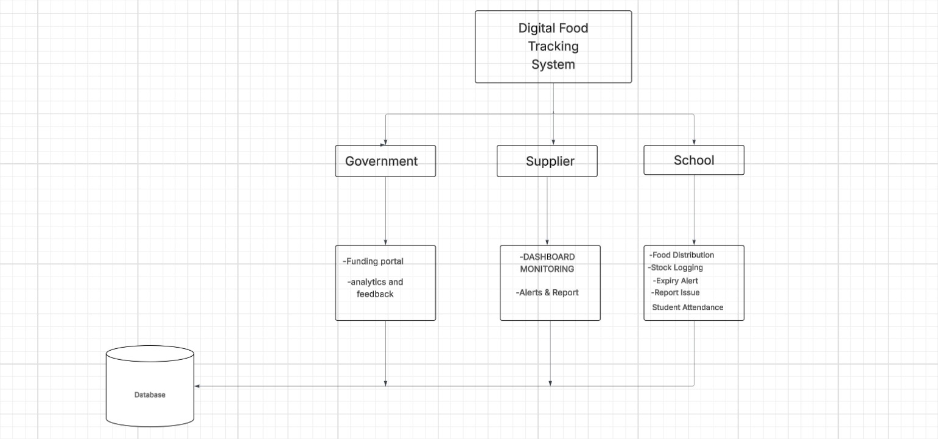

REFERENCES
Department of Basic Education (2024) Internal government documents on National School Nutrition Programme supply chain inefficiencies. Pretoria: Department of Basic Education. (August).
Qila, V.E. and Tyilo, N. (2014) ‘Implementing National School Nutrition Programme (NSNP): how involved are the stakeholders’, Mediterranean Journal of Social Sciences, 5(27), pp. 381–390.
World Food Programme Centre of Excellence against Hunger Brazil (2022) Using digital tools to strengthen South-South cooperation in school feeding. Brasília: WFP Centre of Excellence against Hunger.

